PROPOSAL FOR STRATEGIC PMU SUPPORT AND CAPACITY BUILDING (NASHIK)
Document Type: | Proposal
Version: | 1.0
Date (DD/MM/YYYY): | 22/08/2025
Submitted to: | NASHIK MUNICIPAL CORPORATION
QCI Node: | PPID
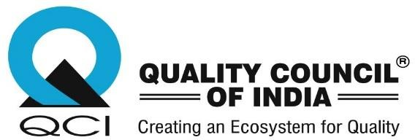

Quality Council of India (QCI) is an autonomous organisation established in 1997, through joint initiative of the Government of India and the Indian industry, pursuant to resolution of the Indian Cabinet in 1996. It is registered as a Society under the Societies Registration Act, 1860 with the mandate to establish and operate the national accreditation system in India and promote quality in all aspects of life, industry, environment, and governance. It is a self-sustaining independent organisation with complete financial, administrative, and functional autonomy. The Department for Promotion of Industry and Internal Trade (DPIIT), Ministry of Commerce and Industry, Government of India is the nodal point in the government for QCI and all matters concerning quality. The Governing Council of the Society is the apex governing organ of QCI and consists of equal representation of government, industry, and other stakeholders. Chairperson, QCI is nominated by the Prime Minister of India.

Regd. Office: 2nd Floor, Institution of Engineers Building, 2, Bahadur Shah Zafar Marg, New Delhi-02 | Ph.: +91-11-2337 9321

Contents
- BACKGROUND AND CONTEXT……………………………………………………………………………………………………3
- ABOUT QCI…………………………………………………………………………………………………………………………………3
- CONSTITUENT BOARDS OF QCI…………………………………………………………………………………………………..4
- OBJECTIVE 4
- SCOPE OF WORK……………………………………………………………………………………………………………....5
- METHODOLOGY …………………………………….………………………………………………………………………... 6
- DELIVERABLES…………………………………………………………………………………………………………………………….6
- TIMELINES…………………………………………………………………………………………………………………………………..6
- FINANCIALS…………………………………………………………………………………………………………………………………7
- TERMS OF REFERENCE……………………………………………...………………………………………………………7

- BACKGROUND AND CONTEXT

  - Institutional Backbone for Implementation
Nashik envisions becoming a leading city in sanitation and hygiene. To realize this goal, a dedicated PMU serves as a strategic anchor—enabling data-driven planning, robust monitoring, and timely interventions. It ensures that each parameter under SBM Protocols is methodically addressed through expert oversight, structured execution, and seamless interdepartmental coordination, resulting in more accountable and outcome-oriented sanitation reforms.

  - Expert-Driven Reforms and Innovation
By embedding domain experts within the municipal system, the PMU facilitates adoption of innovative sanitation practices, streamlines processes, and enables evidence-based decision-making.

  - Sustainable Impact Through Capacity Building
The PMU strengthens local capacities, optimizes resource allocation, and institutionalizes high-quality service delivery, paving the way for long-term urban sanitation reforms in Nashik.

- ABOUT QCI

MANDATE & STRUCTURE

    - Quality Council of India (QCI) has been set up as a non-profit autonomous society to establish and operate the national accreditation system in the country and to spread the quality movement in India by undertaking a national quality campaign. It was formed by a joint initiative of the Government of India and the Indian Industry associations like the Associated Chambers of Commerce and Industry of India (ASSOCHAM), Confederation of Indian Industry (CII), and the Federation of Indian Chambers of Commerce and Industry (FICCI).

    - QCI has established Constituent Boards, Divisions, and Cells catering to various aspects of quality. Its Boards are full members of international systems of accreditation and have multilateral mutual recognition arrangements (MRAs/MLAs) that allow for international equivalence and recognition of conformity assessment outcomes.

- Being an independent organization concerned with quality, it is the responsibility of QCI to be an equal opportunity employer, gender-sensitive, and accountable to the public through the RTI Act. Having stated that, QCI may be privy to certain information and not make them public, solely to maintain information confidentiality for stakeholders.

CONSTITUENT BOARDS OF QCI

    - National Accreditation Board for Hospitals and Healthcare Providers (NABH):
Provides accreditation to hospitals and other healthcare organizations. NABH is a member of the International Society for Quality in Healthcare (IsQua) and its accreditations are internationally accepted. It is also a member of the Asian Society for Quality in Healthcare (AsQua).

    - National Accreditation Board for Certification Bodies (NABCB):
Provides accreditation to Certification, Inspection, and Validation/Verification Bodies based on assessment of their competence as per international standards. NABCB is a full member of the International Accreditation Forum (IAF), International Laboratory Accreditation Cooperation (ILAC), and Asia Pacific Accreditation Cooperation (APAC).

    - National Accreditation Board for Testing & Calibration Laboratories (NABL): Provides accreditation to testing, calibration, medical laboratories, proficiency testing providers (PTP), and reference material producers (RMP) for a specific scope following the international standards and based on the assessment of technical competence. NABL is a member of the International Laboratory Accreditation Cooperation (ILAC) and Asia Pacific Accreditation Cooperation (APAC).

    - National Accreditation Board for Education & Training (NABET): Has set up a well-established mechanism for overall quality assurance in sectors such as services, education both formal and non-formal, industry, environment, etc.

    - National Board for Quality Promotion (NBQP): Promotes quality across sectors through focused campaigns and strategic engagement with several partner organizations.

OBJECTIVES

The objectives of this strategic consulting engagement are to guide Nashik Municipal Corporation in strengthening sanitation and hygiene outcomes through robust planning and compliance, digital monitoring and transparency, and enhanced institutional capacity and citizen participation.

- Strengthen Planning, Processes & Compliance – Support NMC in developing roadmaps, SOPs, and monitoring systems to align with SBM related activities.

- Enable Digital Monitoring & Transparency – Help design and facilitation of IT tools (portal, dashboards, GIS mapping, mobile app) for real-time tracking, data-driven decision-making, and accountability.

- Capacity & Community Engagement – Train NMC staff and sanitation workers, and foster citizen participation through SHGs, NGOs to ensure sustainable sanitation practices.

Scope of Work

To achieve the objectives, a dedicated Project Management Unit (PMU) shall be established within Nashik Municipal Corporation. The PMU shall comprise one Team Lead, one Solid Waste Management (SWM) Expert, and one MIS Expert. This team will act as the strategic and operational backbone, focusing on strengthening sanitation planning, enabling robust digital monitoring systems, and driving citizen engagement to improve sanitation and hygiene outcomes and ensure Nashik’s sustained progress.

The PMU shall be responsible for the following:

- Gap Assessment & Roadmap
Conduct ward-wise assessments, identify gaps in infrastructure and operations, and draft a strategic roadmap for ODF, GFC, and SBM goals.

- Process Guidelines Implementation
Standardize SOPs for sanitation services, define staff roles, pilot test processes, and enable field validation using geo-tagged tools and citizen feedback.

- Service Delivery & Digital Monitoring
Facilitate IT portal including D2D waste collection with digital logs, GPS vehicle tracking, GVP elimination, and grievance redressal with real-time dashboards among other features

- Stakeholder & Community Engagement
Support SHGs, NGOs, and RWAs for CT/PT management, awareness drives, and citizen participation in cleanliness and feedback campaigns.

- Capacity Building
Train NMC staff, sanitation workers, and ward teams on hygiene protocols, digital systems, and behavior change techniques.

- Field Verification & Reporting
Carry out indicator-based inspections with geo-evidence, use standard checklists, and upload reports to the centralized MIS for actionable insights.

Methodology

Module 1: Assessment Framework Development
QCI shall design a ward-level assessment framework, conduct pilot surveys for refinement, enable structured citizen feedback mechanisms, and facilitate in establishing real-time quality monitoring systems.

Module 2: Process Optimization

Document existing sanitation workflows and map interdependencies to identify inefficiencies and overlaps. Re-engineer processes using RASIC and best practices to improve speed, inclusivity, and accountability.

Module 3: Enhancing Citizen Experience
Gather structured feedback from citizens, SHGs, officials, and workers to validate redesigned sanitation processes. Test IT platforms and grievance systems in the field to assess responsiveness, service quality, and alignment with SBM standards.
7. Deliverables for SBM Nashik Strategic Engagement
- End-to-End Technical and Operational Support- Provide comprehensive assistance to Nashik Municipal Corporation (NMC) for sanitation-related activities, covering planning, execution, and monitoring.
- Gap Assessment Report- Conduct a detailed baseline and gap assessment of current sanitation services and submit a report highlighting existing challenges, inefficiencies, and actionable areas for improvement.
- Standard Operating Procedures (SOPs)- Develop comprehensive SOPs for sanitation-related services incorporating a RASIC matrix for role clarity. Also, document best practices and replicable models for sustainable sanitation management.
- Digital Monitoring Guidelines- Prepare a guideline document for the design and use of a digital monitoring platform to track sanitation activities, service delivery, and outcomes.
- Community Engagement & Capacity Building- Design and implement stakeholder engagement programs. Also, conduct training and capacity-building workshops for NMC staff, contractors, and community representatives to ensure ownership and sustainability.
- Monitoring & Reporting Mechanism- Undertake continuous monitoring through structured field verifications and submit quarterly progress reports to NMC with key findings, compliance status, and recommendations for corrective action.
8. Timeline
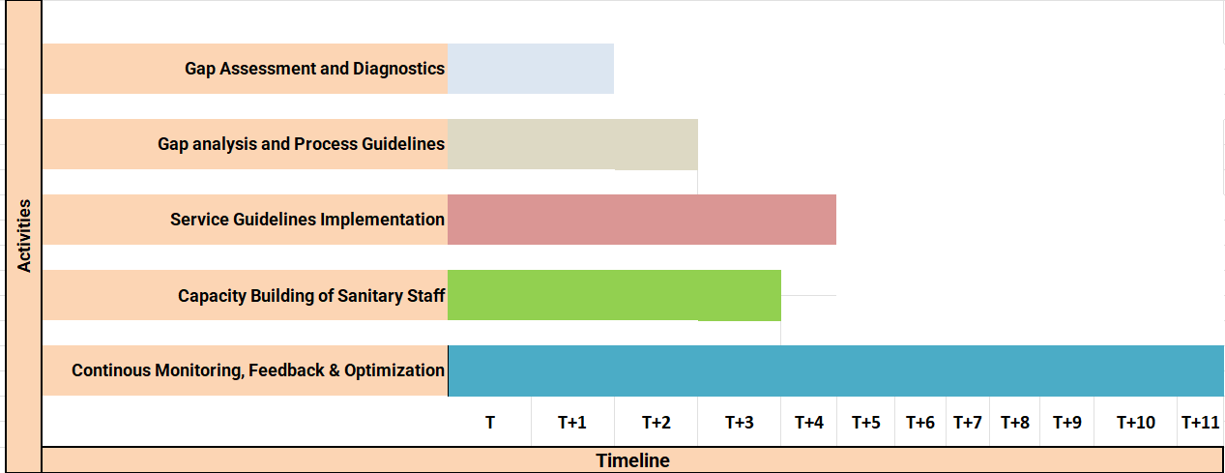
Note*: T is the month of PMU Setup

9. Financials
The proposed financials are as follows:

Header | Cost/Month | Nos. | Total (₹)
Team Lead | 1,50,000 | 1 | 1,50,000
SWM Expert | 1,25,000 | 1 | 1,25,000
MIS Expert | 1,00,000 | 1 | 1,00,000
Subtotal – PMU |  |  | 3,75,000
Central Support Team and Logistics (Standard Cost) | 1,25,000 |  | 1,25,000
Sub Total |  |  | 5,00,000
Admin Charges (12% of total cost) |  |  | 60,000
Grand Total |  |  | ₹5,60,000
*The proposed cost is per month cost of PMU. Total will be based on the number of months of engagement.

10. TERMS OF REFERENCE

NMC shall issue a work order including the deliverables and costing.

NMC shall provide access to relevant SBM systems and data, including: SBM Urban Portal and associated ward-level data, Swachh Survekshan dashboard, GFC star-rating portal, and ODF+ protocols, Any analytics/data sources (e.g., existing MIS, citizen complaint apps, vehicle GPS logs).

NMC shall facilitate coordination with key stakeholders such as NGO’s, contractors, SHGs, and IT service providers.

Help organize structured feedback sessions with internal stakeholders (sanitation staff, inspectors, Safai Karmis).

Providing workflow documents and technical architecture of existing SBM processes (collection, CT/PT management, IEC, grievance system).

Completion Certificate- At the end of the engagement, NMC shall issue a Completion Certificate to QCI

